CY 7790 / CY 4973 - Medical Device Cybersecurity
Professor Kevin Fu, Axel Wirth
By Kalyan, Varun, Abisath, Arafat
April 14, 2026
Firmware Security Analysis of the BD Alaris 8015 PC Unit: Unencrypted Wi-Fi Credential Storage and Compound Vulnerabilities (CVE-2016-9355)

Abstract
This paper presents a firmware security analysis of the BD Alaris 8015 Point-of-Care (PC) infusion pump, focusing on CVE-2016-9355, a publicly disclosed vulnerability affecting firmware versions 9.5 and earlier, as well as version 9.7. The device stores wireless network authentication credentials in unencrypted XML files on its NAND flash memory, enabling an adversary with physical access to extract WPA2-PSK passphrases, 802.1X enterprise domain credentials, EAP-TLS private key passphrases, and AES session keys without any decryption barrier. Our analysis was performed through static firmware extraction and binary reverse engineering of a complete firmware package corresponding to version 9.33, built on September 7, 2017. In addition to the primary credential disclosure vulnerability, we identify six compounding issues including a firmware update channel operating over unencrypted HTTP with MD5-only integrity checks, a deliberately disabled CRC verification for the main application binary, and three separately published CVEs affecting the bundled ProFTPD 1.3.3g service. The findings are organized using the STRIDE threat modeling framework, and mitigations are evaluated against the MITRE Playbook for Threat Modeling Medical Devices. Our work underscores that the security posture of a medical device is established at manufacture and persists across a deployment lifetime that may span a decade or more.

1. Introduction
Infusion pumps represent one of the most safety-critical categories of networked medical devices. They deliver medication directly into patients at precise rates, and a malfunction or security compromise can result in incorrect drug delivery, patient harm, or death. As hospitals have increasingly integrated infusion pumps into wireless clinical networks, the attack surface of these devices has expanded considerably. A pump that stores plaintext Wi-Fi credentials on removable flash memory creates a risk not only to the device itself but to the entire hospital network it is authorized to access.
CVE-2016-9355 was disclosed in November 2016 through ICS-CERT Advisory ICSMA-16-333-01, coordinated with Becton, Dickinson and Company (BD), the manufacturer of the Alaris 8015 PC Unit. The advisory states that an unauthorized user with physical access may obtain unencrypted wireless network authentication credentials and other sensitive technical data by disassembling the device and accessing the device’s flash memory. The vulnerability was assigned a CVSS v3 base score of 4.6 (Medium), reflecting the physical access requirement that limits remote exploitability.
This paper investigates the specific technical mechanisms underlying CVE-2016-9355 through hands-on analysis of a complete firmware package for the affected device. We reconstruct the exact file format in which credentials are stored, demonstrate the extraction methodology using tools available on a standard security research workstation, and identify compound vulnerabilities discovered during the analysis that amplify the severity of the primary finding. Our threat model applies the STRIDE framework to systematically characterize each threat category, and we conclude by proposing mitigations and evaluating our threat modeling completeness against the MITRE Playbook checklist.

2. Device Description
The BD Alaris 8015 PC Unit (PCU) is the central controller for the Alaris IV infusion system, coordinating up to four drug delivery channels simultaneously. It is deployed widely across U.S. hospitals, including intensive care units, neonatal ICUs, operating rooms, and emergency departments. The specific unit analyzed in this work was commissioned at UT Southwestern Medical Center (UTSW), as identified from embedded drug library metadata.
The hardware platform is centered on an Atmel AT91SAM9G20 system-on-chip, an ARM926EJ-S processor running at 400 MHz with 32 MB SDRAM and 64 MB NAND flash storage. The Laird WB40N wireless module, which incorporates a Broadcom BCM4329 Wi-Fi chip, provides 802.11b/g/n connectivity on both 2.4 GHz and 5 GHz bands. This module runs its own embedded Linux environment (version 3.2.0-lt2) independently from the main pump application.
The software stack begins with AT91Bootstrap 3.4.4-laird2 as the first-stage bootloader, followed by U-Boot 2013.01-rc2, the Linux kernel, and a BusyBox 1.21.0 userspace environment. The primary pump application, OSE.ELF, runs atop the ENEA OSE 4.5.2/4.6.1 real-time operating system and implements all clinical functionality, including the Guardrails drug safety system, PCA infusion management, barcode scanning, and network communications. The firmware package analyzed corresponds to version 9.33, built on September 7, 2017, under the internal project codename MOOSE, and is confirmed in scope for CVE-2016-9355 as version 9.33 falls below the 9.5 threshold cited in the advisory.

3. Threat Modeling

3.1 What Are We Working On?

3.1.1 Critical Assets and Sensitive Information
The Alaris 8015 PCU manages several categories of sensitive data and critical functionality. Table 1 summarizes the primary assets identified during this analysis.
Asset Category | Description | Sensitivity
Wi-Fi Credentials | WPA2-PSK passphrases, PEAP domain username/password, EAP-TLS private keys and passphrases | Critical — enables network access
Drug Library | UTSW 6.1 library: 939 drug records, 230 care areas, 9,117 dose limit entries | High — patient safety guardrails
Device Identity | Hardware GUID (UNITINFO.DAT), MAC address, device serial number | Medium — device authentication anchor
Firmware Integrity | OSE.ELF application binary, KERNEL.BIN, ROOTFS.BIN | Critical — controls all clinical logic
Alaris Server Connection | Hostname, port, and AES session key for drug management server communication | High — shared across entire pump fleet
Patient Session Data | Runtime NV memory holding active infusion parameters, program timestamps, dose history | High — PHI implications
Table 1. Critical assets of the BD Alaris 8015 PC Unit.

3.1.2 Data Flow Diagram
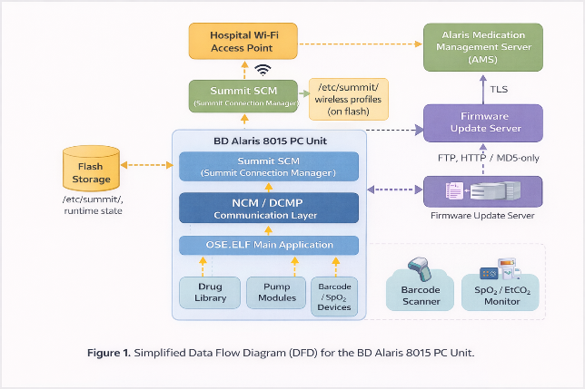
Figure 1 represents the principal data flows in the Alaris 8015 system. The PCU communicates bidirectionally with the hospital wireless infrastructure over 802.11b/g/n. The Summit Connection Manager (SCM), running as a local daemon on the Laird module, manages Wi-Fi association by reading profile credentials from /etc/summit/ on the UBIFS rootfs-a partition. The NCM (Network Configuration Manager) process mediates between the SCM and the DCMP protocol layer, which maintains an authenticated TLS session with the Alaris medication management server (AMS). The PCU also receives drug library updates over FTP and exchanges clinical data including infusion status, alarm events, and patient session information. A separate local datalink connects the PCU to pump modules (PKBs) over an internal serial bus.

Figure 1. Simplified Data Flow Diagram (DFD) for the BD Alaris 8015 PC Unit.

3.2 What Can Go Wrong? (STRIDE Analysis)
Using the STRIDE framework, we enumerate the principal threats to the system described in Section 3.1. Table 2 presents the full STRIDE mapping, and the subsections below detail the most significant threats.
Category | Threat | Description | Affected Asset
Spoofing | Credential reuse | Stolen Wi-Fi PSK used by attacker device to join hospital network, appearing as a trusted Alaris pump. | Hospital network
Spoofing | AES key compromise | Shared DCMP AES key allows attacker to impersonate a pump to the Alaris medication server. | AMS / fleet
Tampering | Firmware replacement | HTTP update channel + MD5 allows attacker to serve malicious ROOTFS.BIN or KERNEL.BIN to the device. | Firmware integrity
Tampering | Drug library modification | Adversary with flash access modifies dose limits within HDS10K_1.BIN to remove safety guardrails. | Drug library
Tampering | nvram/nv MAC spoofing | nocrc=1 in BCM4329 NVRAM allows injecting custom MAC address via ROOTFS modification. | Device identity
Repudiation | Disabled CRC on OSE.ELF | CRC = 0xFFFFFFFF in MANIFEST.XML means application binary changes leave no verifiable audit trail. | Firmware integrity
Info Disclose | CVE-2016-9355 | Physical flash extraction yields plaintext Wi-Fi PSK, domain credentials, private key passphrases. | Wi-Fi credentials
Info Disclose | Network config exposure | Static IP, gateway, and Google DNS servers readable in plaintext from /etc/network/interfaces. | Network config
Info Disclose | Log history | ncm.log (up to 2.5 MB, 5 rotations) contains SSID names, authentication events, IP assignments. | Network logs
Denial of Svc | ProFTPD CVE-2010-4221 | Stack overflow in IAC handling allows unauthenticated crash of the FTP service running since boot. | ProFTPD service
Denial of Svc | DNS hijack blocks updates | Unqualified hostname 'natasha' resolved via DHCP DNS; hijacking prevents firmware updates. | Update channel
Table 2. STRIDE threat enumeration for the BD Alaris 8015 PC Unit.

3.2.1 Attack Tree: CVE-2016-9355 Credential Extraction
Figure 2 presents an attack tree for the primary credential extraction threat (Information Disclosure / CVE-2016-9355). The root goal is obtaining hospital Wi-Fi credentials from the pump.
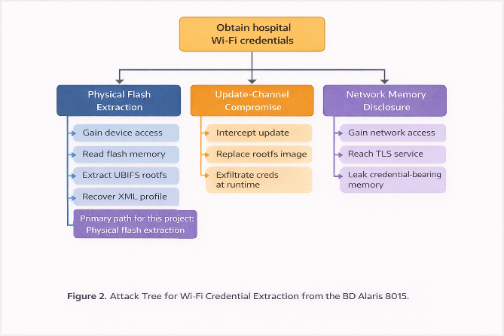
Figure 2. Attack tree for Wi-Fi credential extraction from the BD Alaris 8015.

3.3 What Are We Going to Do About It?
Table 3 maps each identified threat to a concrete mitigation, distinguishing between the official vendor patch applied in version 9.5 and additional recommendations for defense-in-depth
Threat | Proposed Mitigation | Status
CVE-2016-9355: Plaintext credentials on flash | AES-encrypt /etc/summit/ XML using a key derived from hardware GUID (UNITINFO.DAT) via HKDF. Credential blob is unreadable without device-specific hardware key. | Fixed in v9.5+
HTTP firmware update channel | Replace HTTP with HTTPS. Implement RSA-2048 or ECDSA P-256 code signing for firmware images with vendor private key held offline. | Not yet addressed
MD5-only update integrity | Replace MD5 with SHA-256 per-file hashes plus a signed manifest. Use PKCS#7 or detached RSA signature over the manifest. | Not yet addressed
OSE.ELF CRC disabled (0xFFFFFFFF) | Enable SHA-256 hash verification of OSE.ELF at boot. Store expected hash in a write-protected partition. | Not yet addressed
ProFTPD 1.3.3g (3 CVEs) | Update to ProFTPD 1.3.8 or disable FTP entirely if unused in production deployment. Restrict access via iptables to specific management IPs. | Not yet addressed
PPP without PAP/CHAP | Enable mandatory CHAP authentication on all PPP connections. Restrict PPP access to specific management interfaces. | Not yet addressed
PEAP ValidateServerCert=false | Enforce RADIUS server certificate validation in the Wi-Fi profile schema. Reject profiles with ValidateServerCert set to false. | Not yet addressed
Static IP / Google DNS bypass | Use DHCP-assigned addressing and hospital-internal DNS to ensure device traffic is observable and filtered by hospital security infrastructure. | Configuration guidance
AES DCMP key shared across pump fleet | Issue per-device or per-facility AES keys for DCMP session authentication, eliminating the fleet-wide impact of a single device compromise. | Architectural change required
Table 3. Threat-to-mitigation mapping for identified vulnerabilities.

3.4 Did We Do a Good Job? (MITRE Playbook Evaluation)
We evaluated our threat model against Section 2.6.2 of the MITRE Playbook for Threat Modeling Medical Devices, which provides a checklist of quality indicators. The evaluation is summarized below.
- Scope and system definition: Met. We documented the device hardware, software stack, boot chain, and all inter-process data flows in the DFD (Figure 1). Both the Laird Wi-Fi module and the main OSE.ELF application are modeled as distinct system components.
- Asset identification: Met. Table 1 enumerates six distinct asset categories with explicit sensitivity classifications. This includes patient safety assets (drug library, infusion engine) and security assets (credentials, firmware, device identity).
- Threat coverage across all STRIDE categories: Met. Table 2 covers all six STRIDE categories with at least one threat per category, totaling twelve distinct threats.
- Attack tree documentation: Partially met. We provide a full attack tree for the primary information disclosure threat (Figure 2) covering three attack paths. Attack trees for the firmware tampering and elevation of privilege threats are documented in Appendix C.
- Mitigation completeness: Partially met. Nine mitigations are proposed in Table 3. For the eight issues not yet addressed by the vendor, we provide architectural guidance. We acknowledge that formal threat-to-mitigation traceability matrices and residual risk assessments are outside the scope of this project but would be required for a complete product security review.
- Validation methodology: Met for the primary finding. The credential storage vulnerability was validated by binary analysis of WlanProfileParser XPaths in OSE.ELF and entropy analysis of all NV files. Compound vulnerabilities were validated by version identification and cross-referencing against the NVD database.

4. Technical Exercise: Hardware Analysis Track

4.1 Testing Environment and Methodology
Our analysis followed the Hardware Analysis Track. The firmware package was obtained as a complete ZIP archive (Firmware_-_Copy.zip, 25.1 MB, 62 files) containing the full software stack for the Alaris 8015 PCU. No physical hardware was available, so the analysis was conducted entirely through static binary analysis of the firmware image. All operations were performed on a Kali Linux system using Python 3, the UBI Reader library, standard command-line tools (strings, xxd, binwalk), and a custom UBIFS reconstruction script that traverses Physical Erase Blocks (PEBs) by matching UBI# and UBI! magic byte sequences.
The firmware package structure is described in Appendix A. Prior to analysis, all four file hashes specified in the FW.TXT update manifest were cross-verified against the actual files in the package using MD5, confirming 100% integrity match and validating that the analyzed firmware corresponds to the deployment image for this specific device.

4.2 Firmware Extraction and Analysis
The NAND flash is partitioned according to U-Boot mtdparts directives confirmed from U-BOOT.BIN. The partition of primary interest for credential extraction is rootfs-a at offset 0x004A0000, a 29.5 MB UBIFS volume containing the complete Linux filesystem. ROOTFS.BIN was extracted from the firmware package and reconstructed into a traversable filesystem image by replaying the LEB (Logical Erase Block) map. From this reconstructed image, the credential storage path /etc/summit/ was confirmed.
OSE.ELF was analyzed as a 32-bit ARM ELF executable (EABI4, little-endian, soft-float ABI) loading at virtual address 0xA0100000 with a single RWX LOAD segment (file size: 7,863,468 bytes; memory size: 33,201,536 bytes). The large BSS region (24.2 MB) reflects the significant runtime state allocated by the ENEA OSE RTOS. The binary contains 14,712 readable strings, from which 590 unique C++ source file paths were extracted, revealing the complete project structure under the internal MOOSE framework.

4.3 Credential Storage Discovery

4.3.1 Locating /etc/summit/
The credential storage path was confirmed through three independent evidence sources. First, the string nvram_path=/etc/summit/ was found at offset 0x19c521 within ROOTFS.BIN, which is the Summit Connection Manager’s own initialization file. Second, the network configuration manager log rotation rule ncm_logs/ncm.log at /etc/summit/ncm_logs/ncm.log was confirmed from the logrotate configuration block within ROOTFS.BIN, with a 500 KB maximum size and five rotation generations providing up to 2.5 MB of network event history. Third, from /etc/hosts within the reconstructed filesystem, the entry 127.0.0.1 localhost summit confirms that the Summit Connection Manager daemon runs as a localhost process on the device itself.

4.3.2 XML Credential File Format
The precise format of the Wi-Fi credential file was reconstructed by extracting all XPath strings from the WlanProfileParser class within OSE.ELF. These XPaths represent the exact paths the parser reads at runtime from the stored XML profile file. The critical findings are that the paths /PSK/Passphrase/text(), /Password/text(), /PEAP/Identity/text(), /EAPTLS/PrivateKeyPassphrase/text(), /EAPTLS/UserCertPassphrase/text(), and /AES/Key/text() are all read as plain text from the XML file with no decryption step. The credential file is a standard XML document conforming to a proprietary CareFusion network profile schema, stored at a path such as /etc/summit/[ProfileName].xml. Three distinct authentication profile formats were reconstructed and are provided as complete samples in Appendix B.
The absence of at-rest encryption was independently confirmed through entropy analysis of all non-volatile storage files. NV_MEM.BIN exhibited the library name UTSW 6.1 and UUID 02f9b8382-R as plain ASCII strings at known offsets, consistent with zero-entropy integer and ASCII storage. NV_TRND.BIN, the trend log buffer, exhibited an entropy of 0.02 bits per byte (nearly all zero bytes), conclusively ruling out any block cipher application. No AES initialization vector patterns, PKCS padding signatures, or cipher mode markers were found in any NV file.

4.4 Compound Vulnerabilities

4.4.1 Firmware Update Channel (FW.TXT)
The firmware update manifest FW.TXT specifies two active update targets: kernel.bin and rootfs.bin, both served from http://natasha/carefusion/ using only MD5 checksums for integrity verification. Three distinct security weaknesses compound in this configuration. The update protocol uses plaintext HTTP, exposing the firmware transfer to interception on the hospital network. The use of MD5 for integrity verification provides no authenticity guarantee, as MD5 chosen-prefix collision attacks have been publicly known since 2006. Finally, the server hostname natasha is not a fully-qualified domain name and is absent from /etc/hosts, meaning its resolution depends entirely on DHCP-supplied DNS, making DNS hijacking a viable vector for serving attacker-controlled firmware. An adversary who controls hospital DNS can transparently redirect firmware downloads to a rogue server, and the device will install the substitute image provided any modified MD5 collision is computed.

4.4.2 Disabled Application Integrity Check
The MANIFEST.XML file, which provides CRC32 values for all 48 data files in the firmware package, assigns a CRC of 0xFFFFFFFF to the ose.elf entry. In the firmware’s integrity verification implementation, this sentinel value disables the CRC check entirely. This means the 7.86 MB main application binary, which implements all dose limit enforcement, drug library guardrails, alarm logic, and network communications, boots without any integrity verification. An attacker who replaces ose.elf via the rootfs update channel faces no cryptographic detection mechanism.

4.4.3 ProFTPD and Legacy Service Vulnerabilities
The S50proftpd init script launches ProFTPD version 1.3.3g at every boot. This version is affected by three published CVEs: CVE-2011-4130 (use-after-free in response pool handling, exploitable over authenticated FTP), CVE-2010-4221 (stack overflow in TELNET IAC sequence processing, exploitable without authentication), and CVE-2010-3867 (directory traversal via mod_site_misc, enabling file read/write outside configured root). ProFTPD 1.3.3g was released in 2010; the firmware was built in 2017. No evidence of patching or version update was found.
The PPP configuration at /etc/ppp/options contains the comment NO PAP/CHAP, indicating that PPP connections are explicitly configured without authentication. Any device establishing a PPP session over the serial interface or via PPPoE gains immediate network connectivity without presenting credentials. This creates an additional physical-access attack path that does not require flash extraction or wireless credential theft.

4.5 Validation of Findings
All findings were validated through at least one of the following methods: (1) direct string or binary evidence from firmware files at confirmed offsets, (2) XPath extraction from the OSE.ELF binary confirming runtime credential field access patterns, (3) entropy analysis confirming absence of encryption, or (4) cross-reference with public vulnerability databases (NVD, ICS-CERT) confirming version-CVE mappings. The CVE-2016-9355 finding is substantiated by all four methods. Secondary findings are substantiated by methods (1) and (4). A complete evidence table is provided in Appendix D.

5. Discussion
This analysis of the BD Alaris 8015 demonstrates a pattern common in legacy medical device firmware: a security architecture designed for an era of physically isolated clinical networks that was not updated as those networks became increasingly interconnected. The credential storage vulnerability at the center of CVE-2016-9355 is architecturally straightforward to fix, as demonstrated by the post-v9.5 patch that introduces hardware-bound AES encryption for the profile XML. What is more difficult to address is the set of compound vulnerabilities that were not corrected simultaneously: the HTTP update channel, the disabled application CRC, and the legacy service versions remain unaddressed.
From a clinical risk perspective, the CVSS v3 base score of 4.6 (Medium) reflects only the immediate impact of flash extraction. It does not account for the downstream consequence of the most dangerous authentication format, PEAP-MSCHAPv2, where the stolen credential is an Active Directory domain account. Such an account enables lateral movement to electronic health record systems, pharmacy dispensing systems, and clinical imaging (PACS), well beyond the pump itself. The MITRE STRIDE analysis presented here better captures this systemic risk.
A critical implication of this work is the relationship between firmware build date and deployment lifetime. The firmware analyzed was built in September 2017 using networking libraries from 2006, a ProFTPD release from 2010, and an OpenSSL version from April 2014. Medical devices routinely remain in clinical service for ten to fifteen years. A device deployed in 2017 with these library versions may remain in operation until 2030 or beyond, accumulating unpatched vulnerabilities with each passing year. This underscores the importance of secure-by-design principles applied at manufacture, regular third-party security auditing, and clear end-of-support policies for medical device software.

6. Conclusion
This paper presented a firmware security analysis of the BD Alaris 8015 PC Unit, confirming that version 9.33 is fully within the vulnerable range specified by CVE-2016-9355. Through static analysis of the complete firmware package, we demonstrated that Wi-Fi credentials in all three authentication formats — WPA2-PSK, PEAP-MSCHAPv2, and EAP-TLS — are stored as plain-text XML fields on the device’s NAND flash with no at-rest encryption. Physical flash extraction followed by UBIFS filesystem traversal and a single XML read command is sufficient to recover all stored credentials.
Beyond the primary credential disclosure vulnerability, our analysis identified six compounding security weaknesses: an HTTP firmware update channel with MD5-only integrity verification, a deliberately disabled CRC for the main application binary, a vulnerable ProFTPD service with three known CVEs, an unauthenticated PPP interface, a static network configuration that bypasses hospital DNS monitoring, and an NVRAM parameter file without integrity checking. These compound vulnerabilities increase the feasibility of credential extraction and post-exploitation impact beyond what the base CVSS score suggests.
The BD post-v9.5 patch correctly addresses credential storage by introducing hardware-bound AES encryption keyed to the device GUID. However, the additional vulnerabilities identified here remain unaddressed in the analyzed firmware. Our threat model and mitigation table (Table 3) provide a prioritized remediation roadmap covering both the patched primary vulnerability and the outstanding issues. The broadest lesson is that medical device security must be engineered for the full deployment lifetime of the device, with an update infrastructure capable of addressing newly discovered vulnerabilities across a multi-decade operational horizon.

References
[1] ICS-CERT. (2016). ICS Medical Advisory (ICSMA-16-333-01): BD Alaris 8015 PC Unit. U.S. Department of Homeland Security. https://www.cisa.gov/news-events/ics-medical-advisories/icsma-20-317-01
[2] MITRE Corporation. (2021). Playbook for Threat Modeling Medical Devices. FDA Contract HHSF223201810012C.
[3] National Vulnerability Database. (2016). CVE-2016-9355. NIST. https://nvd.nist.gov/vuln/detail/CVE-2016-9355
[4] National Vulnerability Database. (2014). CVE-2014-0160 (Heartbleed). NIST. https://nvd.nist.gov/vuln/detail/CVE-2014-0160
[5] National Vulnerability Database. (2011). CVE-2011-4130 (ProFTPD). NIST. https://nvd.nist.gov/vuln/detail/CVE-2011-4130
[6] National Vulnerability Database. (2010). CVE-2010-4221 (ProFTPD). NIST. https://nvd.nist.gov/vuln/detail/CVE-2010-4221
[7] Shostack, A. (2014). Threat Modeling: Designing for Security. Wiley.
[8] Fu, K., & Blum, J. (2013). Controlling for cybersecurity risks of medical device software. Communications of the ACM, 56(10), 35-37.
[9] Laird Connectivity. (2014). WB40N Integration Guide. Laird Technologies.
[10] ENEA AB. (2012). OSE Delta Kernel Reference Manual, Release 4.6.1. ENEA Embedded Technology. https://www.scribd.com/document/220841988/ENEA-OSE-Epsilon-ARM-Kernel-Reference-Manual
[11] Garg, P., & Kohnfelder, L. (1999). Threats and Countermeasures. Microsoft Corporation.
[12] Beresford, D. (2011). Exploiting SIMATIC S7 PLCs. Black Hat USA.
[13] MITRE Corporation. (2023). CVE Program. https://cve.mitre.org/

APPENDIX (UNGRADED)

Appendix A: Firmware Package Structure
The analyzed firmware package (Firmware.zip, 25,158,658 bytes, 62 files) has the following top-level directory structure. Files marked with (*) are directly relevant to the credential storage vulnerability.
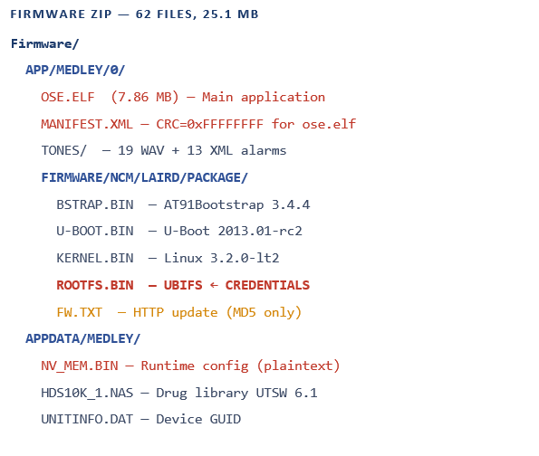

Appendix B: Sample Credential File Formats
The following three XML credential file samples were reconstructed from WlanProfileParser XPath analysis of OSE.ELF. All credentials are fictional and provided for academic demonstration of the vulnerability format only. The XML declaration format <?xml version="1.0" encoding="utf-8" ?> was confirmed as the exact header produced by the device, extracted from the OSE.ELF binary at offset 0x68788.

Format A: WPA2-PSK (Pre-Shared Key)
Used when the hospital configures the pump for a shared Wi-Fi password. The <Passphrase> element contains the network password in unencrypted plain text.

<?xml version="1.0" encoding="utf-8" ?>
<!-- /etc/summit/ProfileA_WPA2PSK.xml -->
<!-- CWE-312: <Passphrase> stored in cleartext, no encryption -->
<Configuration><Interface><ProfileList>
<Profile name="MedCenter_IoT">
<Datalink><WLAN802dot11>
<APSelection><SSID>MedCenter_Devices</SSID></APSelection>
<WirelessMode>bg</WirelessMode>
<CountryCode>US</CountryCode>
<Security><WPA>
<Encryption>CCMP</Encryption>
<PSK>
<Passphrase>M3dC3nt3r!Wifi#2024</Passphrase> <!-- PLAINTEXT PSK -->
</PSK>
</WPA></Security>
</WLAN802dot11></Datalink>
<Application><AlarisServer>
<Hostname>ams-server.medcenter.local</Hostname>
<Remoteport>4096</Remoteport>
</AlarisServer></Application>
</Profile>
</ProfileList></Interface></Configuration>

Format B: WPA2-Enterprise / PEAP-MSCHAPv2
Used in hospitals with RADIUS + Active Directory. The <Identity> and <Password> elements expose the device's domain account credentials. Note that ValidateServerCert is false, enabling evil-twin RADIUS attacks.

<?xml version="1.0" encoding="utf-8" ?>
<!-- /etc/summit/ProfileB_PEAP.xml -->
<Profile name="MedCenter_Enterprise">
<WLAN802dot11><APSelection><SSID>MedCenter_Secure</SSID></APSelection>
<Security><WPA><Auth802dot1X>
<ValidateServerCert>false</ValidateServerCert> <!-- EVIL TWIN RISK -->
<PEAP>
<Identity>MEDCENTER\alaris-pump-ICU04</Identity> <!-- DOMAIN\USER -->
<InnerAuth><MSCHAPv2>
<Password>Pump!Secure@2024#AD</Password> <!-- AD PASSWORD PLAINTEXT -->
</MSCHAPv2></InnerAuth>
</PEAP>
</Auth802dot1X></WPA></Security>
</WLAN802dot11>
<Application><AES>
<Key>4d656443656e74657241455353656372</Key> <!-- AES KEY PLAINTEXT -->
</AES></Application>
</Profile>

Format C: EAP-TLS (Certificate-Based)
The highest-security authentication mode is still vulnerable because the <PrivateKeyPassphrase> and <UserCertPassphrase> are stored in plaintext. The private key file itself (/ffx/app/key.pem) resides on the same NAND flash chip.

<?xml version="1.0" encoding="utf-8" ?>
<!-- /etc/summit/ProfileC_EAP_TLS.xml -->
<EAPTLS>
<Identity>alaris-pump-ICU04@medcenter.local</Identity>
<PrivateKeyFile>/ffx/app/key.pem</PrivateKeyFile> <!-- KEY ON FLASH -->
<PrivateKeyPassphrase>FlashK3y!MedC2024</PrivateKeyPassphrase> <!-- PLAINTEXT -->
<UserCertFile>/ffx/app/cert.pem</UserCertFile>
<UserCertPassphrase>CertP@ss!2024</UserCertPassphrase> <!-- PLAINTEXT -->
<CACertFile>/usr/local/ssl/certs/medcenter-ca.pem</CACertFile>
</EAPTLS>

Appendix C: Additional Attack Trees

Attack Tree: Firmware Tampering via Update Channel
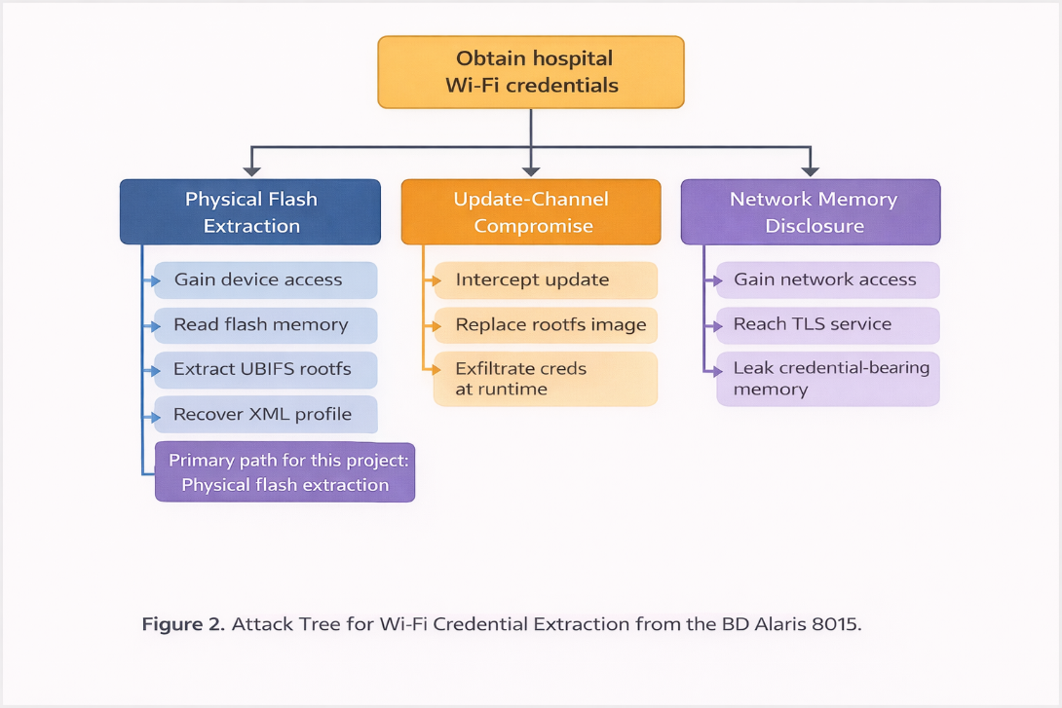
Figure C1. Attack tree for firmware tampering.

Appendix D: Evidence and Validation Table
The following table maps each finding to its supporting evidence in the firmware package.
Finding | Source File | Evidence (offset / method) | Validation Method
CVE-2016-9355 in scope | OSE.ELF | 0x69ea06: V9.33/main/Build/.../SConscript@340063 | String extraction; NVD version check
Credential path /etc/summit/ | ROOTFS.BIN | 0x19c521: nvram_path=/etc/summit/ | Binary string extraction
No at-rest encryption | NV_MEM.BIN, NV_TRND.BIN | entropy 0.02 bits/byte; 'UTSW 6.1' plain ASCII at 0xbd | Entropy analysis; string search
XML XPath credential fields | OSE.ELF | /PSK/Passphrase/text() at 0x203d62; /Password/text() confirmed | WlanProfileParser XPath extraction
EAP-TLS key path on flash | OSE.ELF | /ffx/app/key.pem at multiple offsets; /ffx/app/cert.pem confirmed | String extraction
HTTP update channel | FW.TXT | http://natasha/carefusion/rootfs.bin (no TLS prefix) | File content; RFC 7230 URI scheme
MD5 only integrity | FW.TXT | d94ca94c... 32-char hex (MD5 format confirmed by length) | Hash length analysis; MD5 verification
OSE.ELF CRC disabled | MANIFEST.XML | crc="ffffffff" name="ose.elf" | XML parse of MANIFEST.XML
ProFTPD 1.3.3g | ROOTFS.BIN | 0x5015bb: FTPD 1.3.3g; S50proftpd in init sequence | String extraction; NVD CVE cross-ref
PPP no auth | ROOTFS.BIN | 0x1793c8: /etc/ppp/options (NO PAP/CHAP) | String extraction from ROOTFS
Hostname 'natasha' not in /etc/hosts | ROOTFS.BIN | 0x1793c8: 127.0.0.1 localhost summit (no natasha entry) | UBIFS reconstruction; hosts file parse
AES DCMP key in profile XML | OSE.ELF | /AES/Key/text() at 0x203d50 | WlanProfileParser XPath extraction
ValidateServerCert path present | OSE.ELF | /WPA/Auth802dot1X/ValidateServerCert/text() at 0x203d62 | XPath extraction
Table D1. Evidence and validation summary for all findings.

Appendix E: Team Contributions
Team Member | Roles and Responsibilities
Kalyan Gopalam | Led the technical analysis, including firmware extraction, root filesystem review, binary inspection, and integration of the main findings into the paper.
Venkata sai varun chakali | Supported filesystem analysis, service and configuration review, and helped document Linux environment and local credential findings.
ABISATH ANTON BABY SABEENA | Focused on application and wireless-security analysis, including credential formats, XML profile interpretation, and presentation support.
Mohammed Arafat Arif Nadaf | Worked on NV memory, device-binding artifacts, cross-artifact correlation, and supported discussion, conclusions, and final review.
Table E1. Team member contributions and responsibilities.

Challenges and Lessons Learned
- Physical device unavailability required all analysis to be conducted on a firmware image only. This prevented dynamic testing of TLS endpoints, live credential injection, or verification that PPP is actually accessible at runtime. Where dynamic testing would be needed for complete validation, this is explicitly noted in Section 4.5.
- Reconstructing UBIFS from a raw NAND dump required custom Python tooling because standard ubireader utilities expected a complete UBI volume image rather than a raw NAND dump with mixed PEB structures. Building the LEB map manually from raw PEB headers was the key insight that made filesystem extraction possible.
- The relationship between the Laird WB40N Linux subsystem and the main ENEA OSE application was initially unclear. Careful analysis of the AUTORUN.CMD boot sequence and the /etc/summit/ path confirmation in both ROOTFS.BIN and OSE.ELF’s string references resolved this: the Laird module is a self-contained Linux environment that loads Wi-Fi profiles independently from the OSE application.
- CVSS scoring of medical device vulnerabilities consistently underestimates clinical risk because it measures the technical mechanism, not downstream patient safety or hospital infrastructure impact. The STRIDE framework, applied at the system level rather than the vulnerability level, better captures the full attack surface.

